LESSON ONE (Chapter 1)  
INTRODUCTION: THE SCIENCE OF HUMAN DEVELOPMENT

I. Development Defined: General definition: 3 critical elements

A. Science- based in facts and predictions

B. Diversity- studies all kinds of people

C. Connections between change and time- things change over time

II. Life-Span Perspective (Four Characteristics of Development)

A. Multidirectionality- change is always occurring, and is not constant

1. Critical and Sensitive Periods

B. Multicontextual

1. Historical context

2. Socioeconomic context – “middle class” occupation, education

C. Multicultural-

D. Plasticity- adapting and changing

III. Developmental Study as a Science

A. Scientific Method: 5 Steps ask a question, hypothesis,test, draw conclusions, make the findings avalible

B. Ways to test hypotheses

1. Observation

2. Experimentation

3. Survey

C. Studying development (change) over the life span

1. Cross-sectional

2. Longitudinal

3. Sequential

D. Solutions & Challenges from Scienced: General definition: 3 critical elements

LESSON TWO (Chapter 1, continued)

THEORIES OF HUMAN DEVELOPMENT: FREUD

I. Developmental Theory Defined- systematic statement describing behavior and development

II. Psychoanalytic Theory: Sigmund Freud-view human behavior and development in terms of

unconscious drives and motivations

A. Historical route to the theory – hypnosis and hysteria, frued came up with free association relation treatment instead

B. Freud's beliefs- EVERYTHING can be explained by unconscious memories

C. Freud's proposals – inborn cravings for physical pleasure drive developmentpleasure

D. Freud's theory

1. psychosexual stages

boys experience the Oedipal

Complex, whereas girls experience the Electra Comple

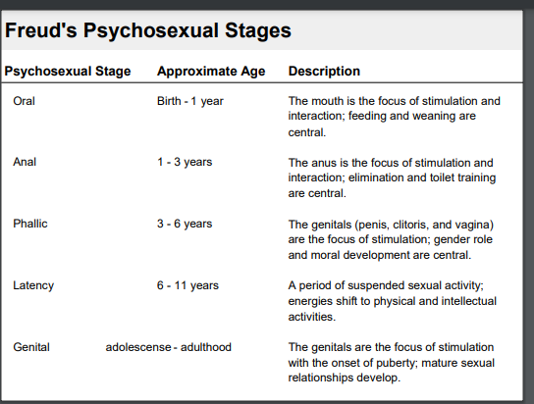

2. three components of personality

I. ID- entirely unconscious

II. EGO- anal stage balances id and limitations of the world

III. SUPEREGO- aka conscienceLesson 3

I. Psychoanalytic Theories (continued)

B. Erik Erikson- For now, all you need to be aware of concerning Erikson is that he :

1. expanded upon Freud’s theory by adding adulthood stages;

2. addressed psychosocial rather than psychosexual aspects of

development; and

3. identified specific developmental tasks for each of his eight stages

of development

II. Behaviorism (Learning Theories)

A. Laws of conditioning

1. Classical (respondent) conditioning – Pavlovs dogs

2. Operant (instrumental) conditioning – re-enforcement of either positive or negative responses ( added or removed)

B. Social learning theory

1. modeling – patterning behavior after another

III. Cognitive Theory- development guided by thoughts.

A. Piaget- Organization, Adaptation- assimilation ( calling a cow dog), Accommodation(when cow is called cow), and Equilibrium.

B. Vygotsky - scaffolding (more mature person showing the way “you want your ball?” and the zone of proximal development (self abilities and aided abilities)

IV. Systems Theories

1. Ecological Theory Bronfenbrenner also identified the chronosystem (dimension of time)

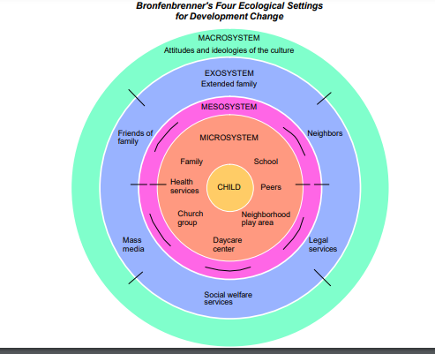

I. Genes and Chromosomes

A. Variations among People

B. Genotype and Phenotype-A person’s phenotype is defined as the actual

appearance and manifest behavior of the individuals

C. Shared and Divergent Genes

D. Male and Female

E. Twins

monozygotic twins (commonly referred to as identical

twins). In approximately 1 of every 250 conceptions

dizygotic (commonly referred to as fraternal

twins), which occurs about three times as often as monozygotic twins and thus

account for approximately 3/4 of all twin pairs.

F. Genetic Interaction

Polygenic- effected by more than one gene

Multifactorial- influenced by factors other than genes

Additive- multiple genes add or take away alittle.

II. Genetic Problems

PRENATAL DEVELOPMENT PART I: NORMATIVE DEVELOPMENT

A. Germinal Period- first 14 days, Blastocyst- inner and outer, implants 10 days after conception, placenta develops in the second week, blood does not mix in the placenta

B. Period of the Embryo (3-8 weeks) . Cephalocaudal (head to tail) - from the top of the body downward

2. Proximodistal (spine to extremities) - from the center of the body outward

Thus, growth will be most rapid at the center (proximodistal) of the head

(cephalocaudal)

4th Week: head takes shape as eyes, ears, nose and mouth start to form. Also, a

miniscule blood vessels that will become the heart begins to pulsate. After 8th week embryo weighs 1 gram. This is now a fetus

C. Period of the Fetus ( 9 weeks-Birth) after 22 weeks after conception the fetus is at the age of viability and can survive outside the mothers uterus if medical care is available. 28 weeks is more expected

D. Birth (40 weeks)- 1st stage (8-10 hours normally) transition to the second sateg when the head moves through the Vagina. 3rd stage placenta detaches itself and psses the same way the baby did.

E. APGAR Scale >7 good, >4 needs assistance breathing, <4 emergency

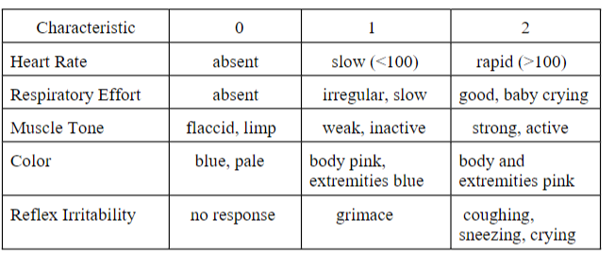

Overview

How Things Can Go Wrong (Teratology is the study of birth defects)

Teratogens- substances and pollution that increase prenatal abnormalities

Determining Risk

timing

amount of exposure

genetic vulnerability- males are more vulnerable to prenatal defects

protective factors- avoid known teratogens, prenatal care, and social support

*nutrition

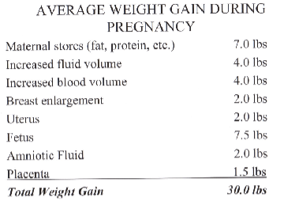

Some Specific Problems

Chromosomal Anomalies

Gene Disorders

Genetic Counseling

LESSON 7

**General Information-**

The average newborn is 20 inches long and weighs 7.5 pounds

- weight: Although infants lose weight in their first three days, weight

typically doubles by 4 months, triples by the end of the first year and quadruples

by 2 years.

- height: infant grows approximately 1 inch per month for the first year.

Physical growth slows in the second year but is still rapid. By 2 years, the average

child weighs 28 pounds and is 34 inches in height. Thus, the typical child reaches

approximately ½ adult height and 20% adult weight by 2 years. (Note that these

are “norms,” or averages, and they apply only to infants in North America.

**Sleep::** They typically

sleep 15-17 hours per day, in 1- to 3- hour sessions. As the infant’s brain matures,

hours of sleep decrease rapidly. For example, for the first two months of life, the

average per day is 14.25 hours. For months 3-5, this average falls to 13.25 hours,

and from 6-17 months is 12.75 hours. Given these averages, it is important to

recognize that there is much variatio

**Brain Development-** Experience-expectant

sculpting is defined as that which is necessary for normal brain maturation.

Experience-dependent brain development, on the other

hand, results from experiences that are unique from one infant to the next

Sensory Systems: Sensation (senses) and Perception (brain recognition) *Once the stimulus that*

*caused these responses is no longer new and different, the individual habituates to*

*this stimulus and their body stops responding to it*

Vision-least developed sense, babies like contrast and patterns.

Audition-relatively acute at birth. High pitched is liked, high frequency causes distress, and pattern

Taste and Smell

Touch and Pain

Wisdom of Evolution

Motor Skills

Reflexes Rooting-finding nipple when touching cheek. Babinski-feet, moro- arms out then in when startled.

Nutrition- Breast Milk is best, exclusive for 6 moths and then continue for up to a year in US.

COGNITIVE DEVELOPMENT: INFANCY

A. Piaget: Sensorimotor Intelligence (Birth-2 years) - General

Information and Characteristics of the Theory

1. Stage 1: Early Reflexes (birth-1 month)

2. Stage 2: Primary Circular Reactions (1-4 months) – repeating actions dual sensitivity

3. Stage 3: Secondary Circular Reactions (4-8 months)- action for a object related goal. Partial object perminanace

4. Stage 4: Coordination of Secondary Circular Reactions (8-12

months)

5. Stage 5: Tertiary Circular Reactions (12-18 months)

6. Stage 6: New Means Through Mental Combinations (18-24

months)

B. Piaget Reconsidered: Three Inaccuracies

1. Strictness of developmental timetable- ages are less strict

2. Completeness of movement from one stage to next

3. The role of context- the way a problem is presented changes outcome

II. LANGUAGE DEVELOPMENT: INFANCY

A. General Information

B. Communication and its Development

C. Sequence of Language Development

1st month: reflexive behaviors only (mostly cries)

• 2-3 months: cries are more differentiated, cooing begins, infant becomes

more social (such as by smiling, paying more attention to what is going on

around him/her)

• 3-6 months: greater variety of sounds (e.g., grunts, squeals, growls)

• 6-7 months: babbling develops--does not have meaning for the baby, though

others may read into the infant’s babbles; gestures such as pointing also

appear

• 7-12 months:

- 8 months: babbling changes as utterances take on a conversational

tone (with pauses, rises and falls in intonation, etc.)

- 9-10 months: comprehension begins (average infant has a 20-30 word

14

receptive language, which refers to the number of words the infant is

capable of understanding [and understanding develops more quickly

than does the ability to speak words]).

- 11-12 months: first approximations of real words occur, referred to as

holophrases (have intention, but not true meaning)

• 16-24 months: naming explosion, for most children characterized by a rapid

rise of nouns in their vocabulary, followed by a rise in the number of verbs

• 18-24 months: sentences appear

Infant-Mother Attachment

What is it? Attachment Defined

Attachment Theory: A Brief Overview

Why do attachments develop?

How do attachments develop?

Three Propositions of Attachment Theory

Proposition one: Interaction and attachment quality

Proposition two: Representational models.

Proposition three: Generalized representational model

Bonus: children reach ½ adult height by 2 years

Nerve cells of brain are called neurons